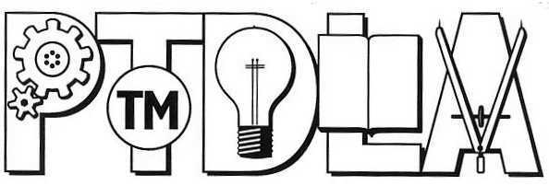
Patent and Trademark Depository Library Association

Executive Committee Resolution
Recognizing

Bill Schilling

Whereas, Bill has served with distinction as the Patent and Trademark Depository Library Program Representative at the New York State Library from October 2001 until his retirement in March 2011;

Whereas, Bill has served on the Archives, Database, and Program & Outreach Committees of the Patent and Trademark Depository Library Association, and was instrumental in getting some of the restored pre-1836 patents added to the PATFT database;

Whereas, Bill has presented on behalf of the PTDLA at American Library Association and New York Library Association conferences, promoting PTDLs and regional resource sharing;

Whereas, Bill has worked tirelessly building relationships with and delivering presentations to local public libraries in New York on behalf of the PTDLP;

Whereas, Bill has collaborated with the New York State legal establishment to organize and deliver accredited Continuing Legal Education (CLE) using training materials based on PTDLP seminars and PTDLP road shows;

Be it resolved that the Patent and Trademark Depository Library Association recognizes and honors Bill Schilling for his leadership and commitment to making patent and trademark information available to the public, and for the many contributions that he has made to both the Patent and Trademark Depository Library Program and the United States Patent and Trademark Office.

Signed,

PTDLA Executive Committee

April, 2011

